Lebanese American University



ELE 443 –Control Systems Lab
Section 31

Mr. Ziad Saoud

Project - Furuta Pendulum

Ali Moussa 202306840
Hussein Itani 202300351
15/12/2025

Table of Contents
Table of Figure 3
Project Overview 4
Introduction 4
System Description 6
1.1 Center of Mass Coordinates 7
1.2 Kinetic Energy 8
1.3 Potential Energy 8
1.4 Euler-Lagrange Formulation 9
1.5 Linearization 10
1.6 Plant State Space Representation 11
1.7 PID Control Design 15
1.8 Advanced Control Design 17
Conclusion 20

Table of Figure
Figure 1 - Rotary inverted pendulum 5
Figure 2 - Code giving the state Matrices 12
Figure 3 - State Space Matrices Values 13
Figure 4 - Plant output with an input of 0 and 0 initial conditions 13
Figure 5 - Plant with 0 input 14
Figure 6 - Output of the system linearized around pi with a square input (yellow-alfa, theta=blue) 14
Figure 7 - Plant with controller 15
Figure 8 - Integral, proportional derivative gain given by the tuner 15
Figure 9 - Alfa output using a PD controller 16
Figure 10 - Theta output using $θ$ PI controller 16
Figure 11 - Diagram of the advanced controller 17
Figure 12 - State feedback 18
Figure 13 - Code of implementing K matrix 18
Figure 14 - Implementing N 19
Figure 15 - Advanced controller (Full state) simulation 19

Project Overview

Introduction
In this project, I will address the modeling and control of a Furuta or Rotary Pendulum, a nonlinear unstable system and a common control systems application. The mathematical model will be developed using the Euler-Lagrange equation, linearized in a neighborhood of the upright configuration, with a state-space representation. Taking into consideration this state-space representation of the mathematical model, control laws using PID controllers will be proposed and optimized for stabilizing the pendulum and controlling the rotational table. All simulation results will be obtained using MATLAB/Simulink environments, tested and validated on a real setup.
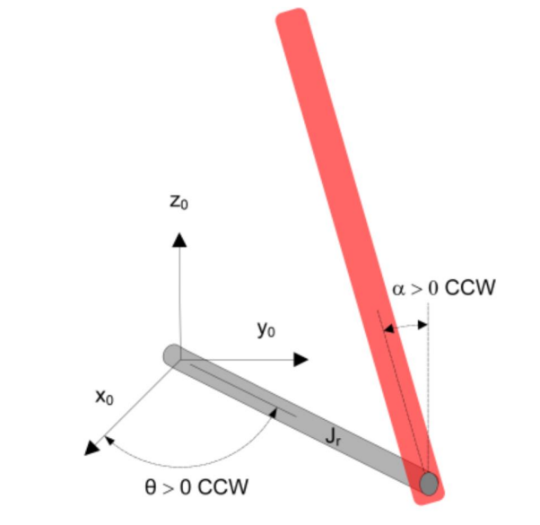
Figure 1 - Rotary inverted pendulum

System Description
The plant (motor) was modeled in Simulink to allow safe and systematic analysis of the system dynamics before hardware implementation. Simulation enables controller design, tuning, and performance evaluation without risking damage to the physical system. In hardware implementation, the real plant replaces the simulated model.
The following variables are defined:
- α: pendulum angle (measured from the vertical upward position)
- θ: arm angle.
- r: arm length (pivot to pendulum joint).
- L_{p}: pendulum length.
- m_{p}: pendulum mass.
- J_{r}: arm equivalent inertia about the vertical rotation axis.
- J_{p}: pendulum moment of inertia about its center of mass.
- b_{r}: viscous damping coefficient for θ.
- bp: viscous damping coefficient for α.
- g: gravitational acceleration.
- u = Vm: motor input (voltage).
- Motor torque model: τ_{m} = K_{t} V_{m}.

1.1 Center of Mass Coordinates
Assuming that the pendulum’s center of mass is at its center, and simplifying the pendulum to a point at its center of mass we have:
$$s_{p}=\left(\begin{matrix}x_{p} \\ y_{p} \\ z_{p}\end{matrix}\right)=\left(\begin{matrix}r cos θ + l sin α cos θ \\ r sin θ + lsin α sin θ \\ lcos α\end{matrix}\right)$$
With l=L_{p}/2.
Thus, the translational velocity of the pendulum is given by:
$$v_{p}=\dot{s_{p}}=\left(\begin{matrix}\dot{x_{p}} \\ \dot{y_{p}} \\ \dot{z_{p}}\end{matrix}\right)=\left(\begin{matrix}-r\dot{θ}sinθ+\frac{L​(\dot{α}cosαcosθ-\dot{θ}sinαsinθ)}{2} \\ r\dot{θ}cosθ+\frac{L​(\dot{α}cosαsinθ+\dot{θ}sinαcosθ)}{2} \\ -\frac{L}{2}​\dot{α}sinα\end{matrix}\right)$$
$$\begin{aligned}⇒V_{com}^{2}=r^{2}\dot{θ^{2}}+l^{2}\dot{α^{2}}+l^{2}\dot{θ^{2}}\sin^{2}{α}+rL\dot{θ\dot{α}}\cos{α}\#\left(1\right)\end{aligned}$$

1.2 Kinetic Energy
The kinetic energy of the system is consisted of 2 different kinetic energies:
$$\begin{aligned}T_{System}=T_{Arm}+T_{Pendulum}\#\left(2\right)\end{aligned}$$

The kinetic energy of the pendulum is expressed as:
$$\begin{aligned}T_{Pendulum}=T_{Pendulum-Rotation}+T_{Pendulum-Transaltion}\#\left(3\right)\end{aligned}$$
$$\begin{aligned}T_{\text{pend,rot}}=\frac{1}{2}J_{p}\dot{α^{2}}\#\left(4\right)\end{aligned}$$

$$\begin{aligned}T_{\text{pend,trans}}=\frac{1}{2}m_{p}V_{com}^{2}\#\left(5\right)\end{aligned}$$Substituting (1) in (5):
$$\begin{aligned}T_{\text{pend,trans}}=\frac{1}{2}m_{p}\left(r^{2}\dot{θ^{2}}+l^{2}\dot{α^{2}}+l^{2}\dot{θ^{2}}\sin^{2}{α}+rL\dot{θ\dot{α}}\cos{α}\right)\#\left(6\right)\end{aligned}$$
$$\begin{aligned}T_{\text{arm}}=\frac{1}{2}J_{a}\dot{θ^{2}}\#\left(7\right)\end{aligned}$$
Substituting (4), (6) and (7) in (2):
$$\begin{aligned}T=\frac{1}{2}J_{a}\dot{θ^{2}}+\frac{1}{2}m_{p}\left(r^{2}\dot{θ^{2}}+l^{2}\dot{α^{2}}+l^{2}\dot{θ^{2}}\sin^{2}{α}+rL\dot{θ\dot{α}}\cos{α}\right)+\frac{1}{2}J_{p}\dot{α^{2}}\#\left(8\right)\end{aligned}$$

1.3 Potential Energy
To calculate the potential energy of the system, the reference considered is the potential energy of the arm, in other words the arm is considered to not have any potential energy.
$$V_{arm}=0 J$$
Thus:
$$\begin{aligned}V_{System}=V_{centre of mass}=mgz=mglcosα\#\left(9\right)\end{aligned}$$

1.4 Euler-Lagrange Formulation
To model the system, we need the equations of motion of the arm and the pendulum the most convenient way to do so, is the use the Euler-Lagrange equation:
$$\begin{aligned}\frac{d}{dt}\left(\frac{∂L}{∂\dot{q_{i}}}\right)-\frac{∂L}{∂q_{i}}=Q_{i}\#\left(10\right)\end{aligned}$$
Where:
- q_{i} is the generalized coordinate (α, $θ$)
- Q_{i} is the sum of forces associated with q_{i.}
- L is the Lagrangian of the system.
$$\begin{aligned}L=T-V\#\left(11\right)\end{aligned}$$
$$\begin{aligned}⇒L=\frac{1}{2}J_{a}\dot{θ^{2}}+\frac{1}{2}m_{p}\left(r^{2}\dot{θ^{2}}+\frac{L^{2}}{4}\dot{α^{2}}+\frac{L^{2}}{4}\dot{θ^{2}}\sin^{2}{α}+rL\dot{θ\dot{α}}\cos{α}\right)+\frac{1}{2}J_{p}\dot{α^{2}}-m_{p}g\frac{L}{2}\cos{α}\#\left(12\right)\end{aligned}$$

For q_{i}= α ,:
$$Q_{α}=-b_{p}\dot{α}=friction on pendulum$$

Applying the Euler Lagrange equation, the final equation of motion for α:
$$\begin{aligned}\left(\frac{m_{p}L^{2}}{4}+J_{p}\right)\ddot{α}+\frac{m_{p}rL}{2}\cos{α} \ddot{θ}-\frac{m_{p}L^{2}}{4}\dot{θ^{2}}\sin{α}\cos{α}+\frac{m_{p}rL}{2}\dot{θ^{2}}\sin{α}-\frac{m_{p}gL}{2}\sin{α}+b_{α}\dot{α}=0\#\left(13\right)\end{aligned}$$
For q_{i}= $θ$:
$$Q_{θ}=-b_{r}\dot{θ}+τ_{m}=friction on arm+motor torque$$
The final equation of motion for $θ$:
$$\begin{aligned}\left(J_{a}+m_{p}r^{2}+\frac{m_{p}L^{2}}{4}\sin^{2}{α}\right)\ddot{θ}+\frac{m_{p}rL}{2}\cos{α} \ddot{α}+\frac{m_{p}L^{2}}{2}\dot{θ\dot{α}}\sin{α}\cos{α}-\frac{m_{p}rL}{2}\dot{α^{2}}\sin{α}+b_{θ}\dot{θ}=0\#\left(14\right)\end{aligned}$$

1.5 Linearization
To finalize our plant the next step is to linearize it about α=0, using the small angle approximation:
- $sin α=α$
- $cos α=1$
- $sin^{2}α=0$
Defining constants:
$$A=J_{r}+m_{p}r^{2}$$
$$B=\frac{1}{2}m_{p}rL_{p}$$
$$C=J_{p}+\frac{1}{4}m_{p}L_{p}^{2}$$
$$D=\frac{1}{2}m_{p}gL_{p}$$
For alpha:

$$\begin{aligned}B \ddot{θ} + C \ddot{α} + b_{p} \dot{α} - D α = 0\#\left(15\right)\end{aligned}$$

For theta:
$$\begin{aligned}A \ddot{θ} + B \ddot{α} + b_{r} \dot{θ} = K_{m} V_{m}\#\left(16\right)\end{aligned}$$
Linearization about p:
- $\tilde{α}=α-π$
- $\sin{α}≈-\tilde{α}$
- $\cos{α}≈-1$
- $\sin^{2}{α}≈0$

For theta:
$$\begin{aligned}A \ddot{θ} - B \ddot{\tilde{α}} + b_{r} \dot{θ} = K_{m} V_{m}\#\left(17\right)\end{aligned}$$

For alfa:
$$\begin{aligned}-B \ddot{θ} + C \ddot{\tilde{α}} + b_{p} \dot{\tilde{α}} + D \tilde{α} = 0\#\left(18\right)\end{aligned}$$

1.6 Plant State Space Representation
For the linearization about 0:
$$x=\left[\begin{matrix}x_{1} \\ x_{2} \\ x_{3} \\ x_{4}\end{matrix}\right]=\left[\begin{matrix}α \\ \dot{α} \\ θ \\ \dot{θ}\end{matrix}\right]$$
$$⇒\dot{x_{1}}=\dot{α}=x_{2}$$
$$⇒\dot{x_{2}}=\ddot{α}$$
We can find x₂ from (15) and (16):
$$\begin{aligned}\dot{x_{2}}=\ddot{α}=\frac{AD α - Ab_{p} \dot{α} + Bb_{r} \dot{θ} - BK_{m}V_{m}}{Δ}, Δ=AC-B^{2}\#\left(19\right)\end{aligned}$$
$$\dot{x_{3}}=\dot{θ}=x_{4}$$
$$\begin{aligned}\dot{x_{4}}=\ddot{θ}=\frac{-BD α + Bb_{p} \dot{α} - Cb_{r} \dot{θ} + CK_{m}V_{m}}{Δ}\#\left(20\right)\end{aligned}$$

Thus, our state space representation becomes, with V_{m} as an input and $\left[\begin{matrix}α \\ θ\end{matrix}\right]$as an output:
$$\dot{x}=\left[\begin{matrix}0 & 1 & 0 & 0 \\ \frac{AD}{Δ} & \frac{ -Ab_{p}}{Δ} & 0 & \frac{Bb_{r}}{Δ} \\ 0 & 0 & 0 & 1 \\ \frac{-BD}{Δ} & \frac{Bb_{p}}{Δ} & 0 & \frac{-Cb_{r}}{Δ}\end{matrix}\right]x+\left[\begin{matrix}0 \\ \frac{- BK_{m}}{Δ} \\ 0 \\ \frac{CK_{m}}{Δ}\end{matrix}\right]u$$
$$y=\left[\begin{matrix}1 & 0 & 0 & 0 \\ 0 & 0 & 1 & 0\end{matrix}\right]x$$
Using the following code the A, B,C and D are given by:
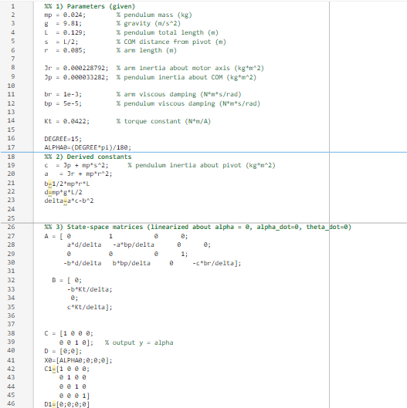
Figure 2 - Code giving the state Matrices
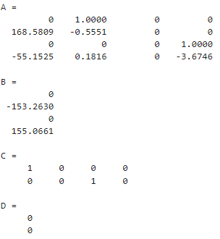
Figure 3 - State Space Matrices Values
With an input of 0 , the plant gives the following output:
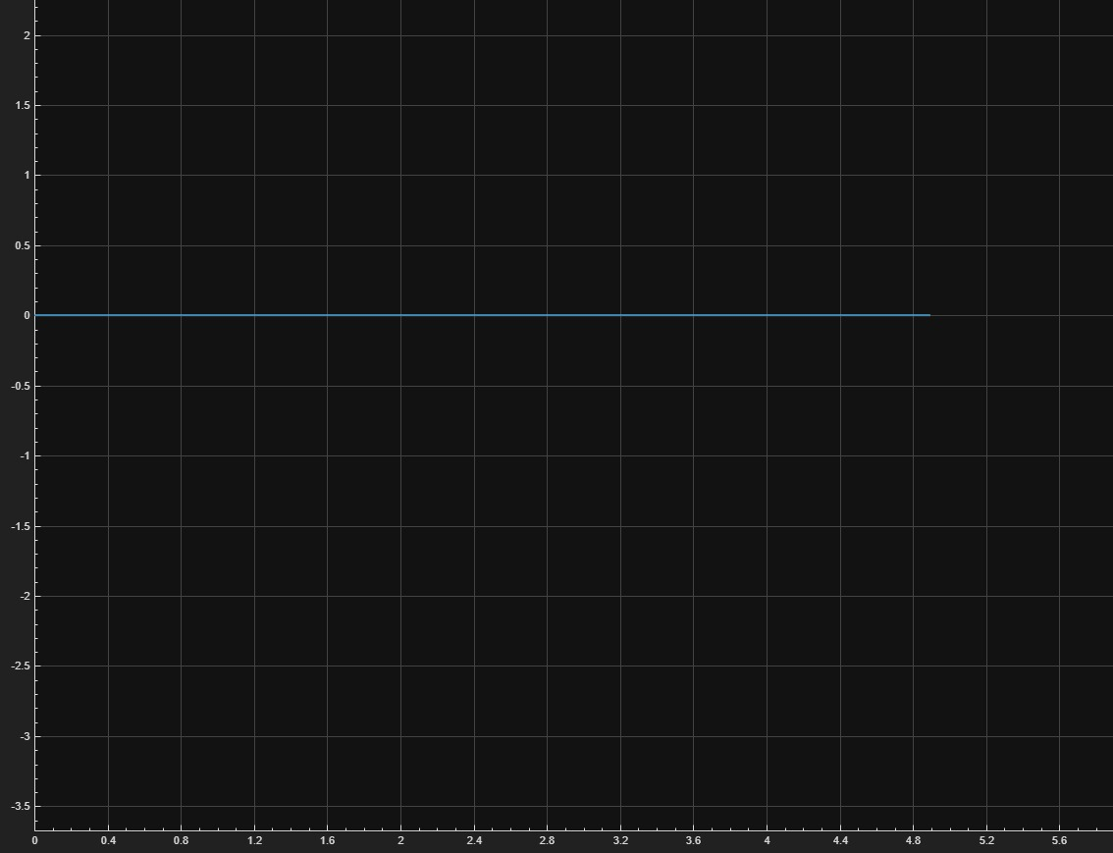
Figure 4 - Plant output with an input of 0 and 0 initial conditions

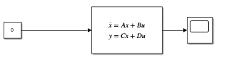
Figure 5 - Plant with 0 input
The linearization about pi gives the same state space representation but with a negative sign for the element in the 2nd row 1st column, the output of such a system with a square wave input of 1 Hz and 1 amplitude:
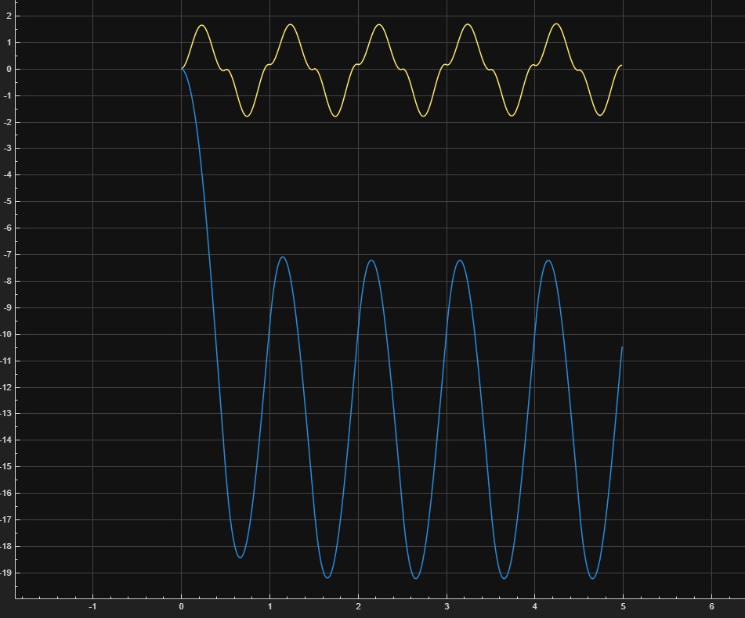
Figure 6 - Output of the system linearized around pi with a square input (yellow-alfa, theta=blue)

1.7 PID Control Design
To control the Furuta pendulum, two independent loops were designed: an inner loop regulating the pendulum angle αα, and an outer loop controlling the arm position θ. A PD controller was selected for the pendulum angle because the upright configuration is naturally unstable and requires fast corrective action. The proportional term provides immediate restoring torque, while the derivative term adds damping that suppresses rapid deviations; an integral term was deliberately avoided because it would slow the response and introduce unnecessary phase lag, making balancing more difficult. In contrast, the arm angle θ represents a stable and slower subsystem, where the objective is precise positioning rather than stabilization. For this reason, a PI controller was chosen: the proportional action drives the arm smoothly toward its reference, and the integral action eliminates steady-state tracking error, while omitting derivative action prevents amplification of measurement noise. Both controllers were tuned using Simulink’s PID Tuner, which linearizes the state-space model around the operating point and automatically generates stabilizing gains. This approach produced stable, well-damped performance for both subsystems.
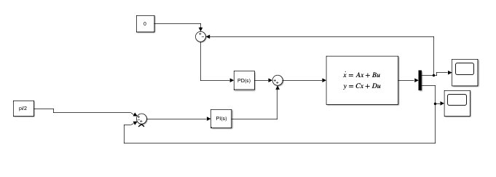
Figure 7 - Plant with controller

The reference of alfa was set to pi/2, the tuner gave the following gains:
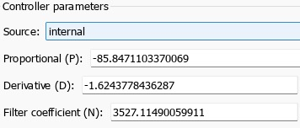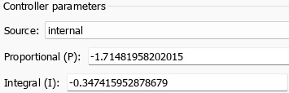
Figure 8 - Integral, proportional derivative gain given by the tuner
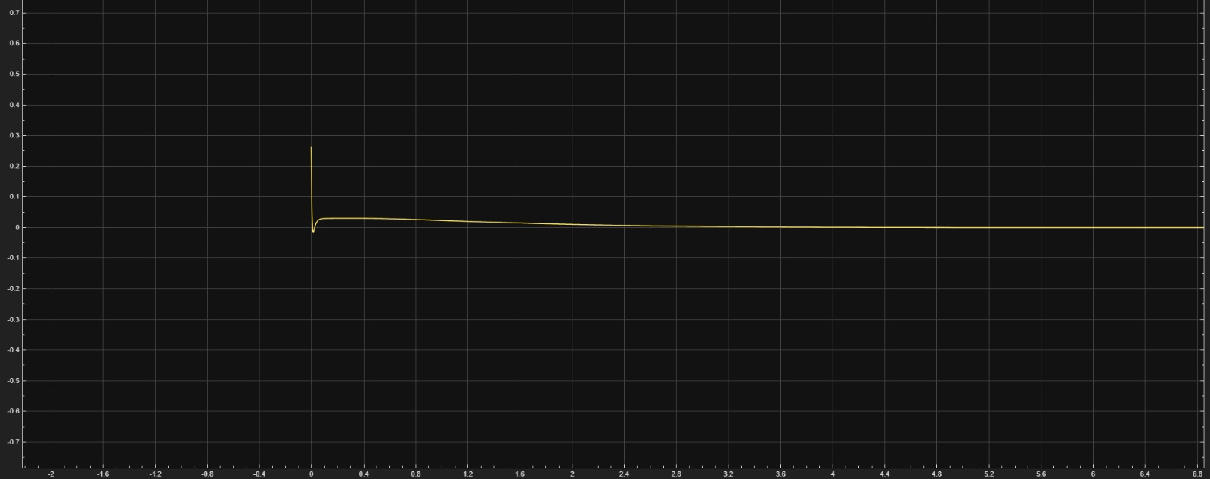
Figure 9 - Alfa output using a PD controller
The system shows a good stabilization for alpha on being zero and stabilized using a PD controller. Here alpha does not need I controller since the I will make it more ocellary which will help in non-stabilizing it. The system here does not need the effect of I since no error accumulated since the pendulum is vertical.
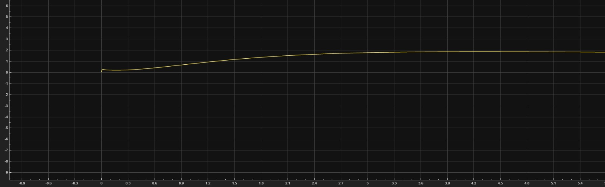
Figure 10 - Theta output using $θ$ PI controller
The system shows a good stabilization using a PI controller. The system here do not need derivative gain since this will damp the ability to stabilize the pendulum.

1.8 Advanced Control Design
The full state-space model of the Furuta pendulum was obtained directly from the linearized equations of motion around the upright equilibrium. Starting from the linearized dynamics:
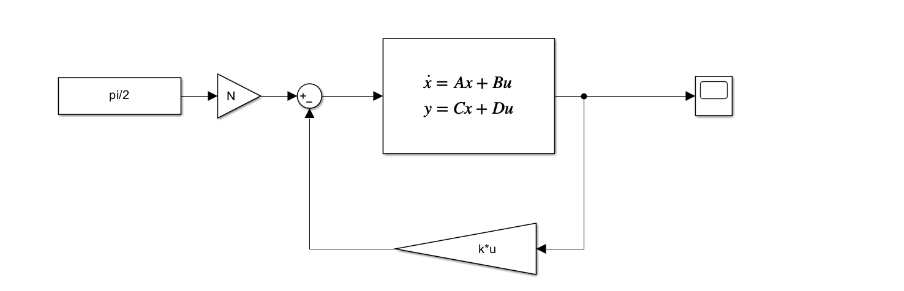
Figure 11 - Diagram of the advanced controller
As in equation 16 and 17:
$$\begin{aligned}B \ddot{θ} + C \ddot{α} + b_{p} \dot{α} - D α = 0\#\end{aligned}$$

$$\begin{aligned}A \ddot{θ} + B \ddot{α} + b_{r} \dot{θ} = K_{m} V_{m}\#\end{aligned}$$
The state space that is going to be used in the system is the same as before as. For A and B, the same procedure, however in full state space our goal is to read $X=\left[\begin{matrix}α \\ \dot{α} \\ θ \\ \dot{θ}\end{matrix}\right]$
To do this the output should be these four variables, the positions and the velocities.
The changes should be done to matrix C in the state space, C will become an Identity matrix 4*4 and D with a 4*1 matrix all of zero elements:

$$y\left(t\right)=\left[\begin{matrix}1 & 0 & 0 & 0 \\ 0 & 1 & 0 & 0 \\ 0 & 0 & 1 & 0 \\ 0 & 0 & 0 & 1\end{matrix}\right]\left[\begin{matrix}α \\ \dot{α} \\ θ \\ \dot{θ}\end{matrix}\right]+\left[\begin{matrix}0 \\ 0 \\ 0 \\ 0\end{matrix}\right]u\left(t\right)$$
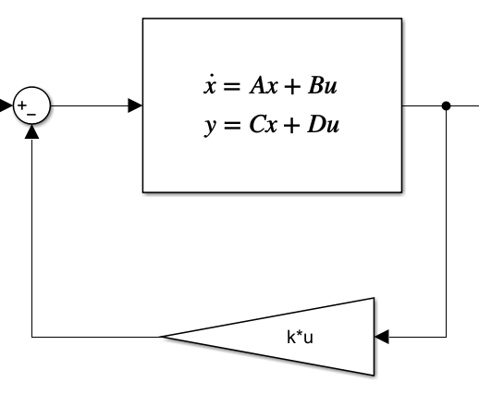
Figure 12 - State feedback
Having this output will give the ability to read all these four states. But to compare these states as feedback to the reference we have we are going to multiply a matrix K by the state matrix:
$$\left[\begin{matrix}K_{1} & K_{2} & K_{3} & K_{4}\end{matrix}\right]*\left[\begin{matrix}α \\ \dot{α} \\ θ \\ \dot{θ}\end{matrix}\right]=\left[constant\right]$$
This multiplication will result in constant they will be compared with the input and feed as an error to the plant. However, to get the matrix K we are going to use the place () command on MATLAB: 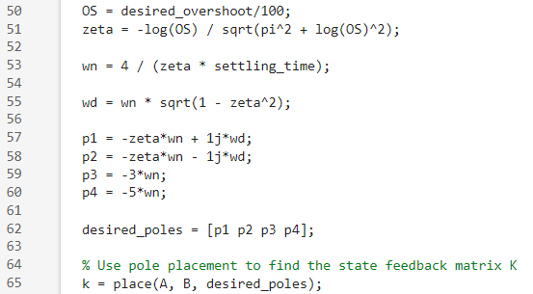
Figure 13 - Code of implementing K matrix
The procedure starts by giving the desired poles of the system needed then put them in a matrix and apply the the place command.
Now regarding the N is also a scaler that holds the folloowing formula:
$$\begin{aligned}N=-\frac{1}{C_{θ}{\left(A-BK\right)}^{-1}B}\#\left(21\right)\end{aligned}$$
$C_{θ}=$is this matrix $\begin{matrix}[0 & 0 & 1 & 0\end{matrix}]$and if used in the equation and multiplyed it will point for $θ$ As shown in the following code:
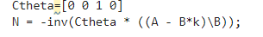
Figure 14 - Implementing N
Finally the input of the plant will be the following :
$$\begin{aligned}u=-Kx+Nr\#\left(22\right)\end{aligned}$$

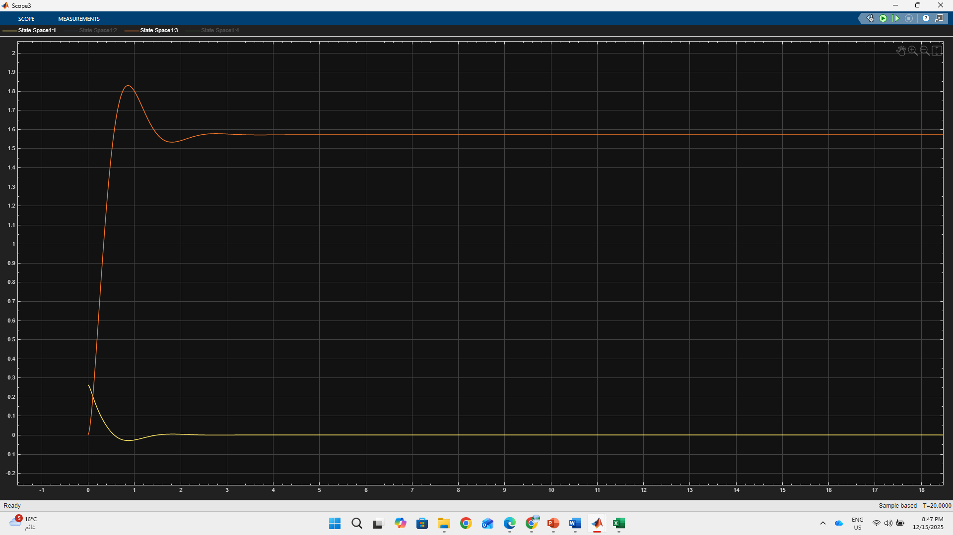
Figure 15 - Advanced controller (Full state) simulation
this time in this simulation the stability of the system is better and more precise for a reel implementation since state space controller is more precise that the PID controller since it reads all the states of the system and analyze it all however the PID only scales the error. While full state reads the state directly from the output.

Conclusion
In this project, the Furuta pendulum system was modeled, linearized, and controlled using a combination of classical control strategies and simulation tools. Starting from the Lagrangian formulation, the nonlinear equations of motion were derived and linearized around the upright equilibrium to obtain a usable state-space representation. Based on the structure of the system, a PD controller was designed for the pendulum angle α, providing fast stabilization and sufficient damping without the drawbacks of integral windup. For the arm angle θ, a PI controller was selected to ensure accurate reference tracking while maintaining smooth motion. Both controllers were tuned using Simulink’s automatic PID Tuner, which linearizes the model internally and computes stabilizing gains that satisfy performance and robustness requirements. Simulation results confirmed that the combined control strategy successfully balances the pendulum while accurately positioning the arm, demonstrating the effectiveness of the model-based design and tuning process.

